BRAC University

CSE230 : Discrete Mathematics

Final Examination

Duration : 105 minutes (2:30 pm – 4:15 pm)

Total Marks : 60 Set: A

**You must answer Questions 1, 2, 3, 4 and each question carries 15 marks.**

Question 5 is a bonus and carries 12 marks.

**ID: Name: Sec:**

**Q01: [CO2] [15 Points]**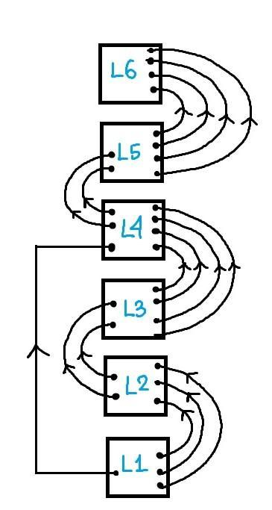

1. How many words can be formed by rearranging the letters of the word “newcampus” so that the first letter and the last letter are not vowels? **[5 points]** 6C2 * 2! * 7! or 7C3 * 3! * 6! = 151200
2. Assume that in the BRAC University Campus, you have the following escalators to move between different levels:

Level 1 to Level 2: 3 escalators

Level 2 to Level 3: 2 escalators

Level 3 to Level 4: 4 escalators

Level 4 to Level 5: 2 escalators

Level 5 to Level 6: 4 escalators

**Level 1 to Level 4:** 1 escalator

***Refer to the diagram on the right.***

**If you are only moving upwards**, find the number of different ways to go from level 1 to level 6 using the given escalators. **[5 points]** (3*2*4+1)*2*4 = 3*2*4*2*4 + 2*4 = 200

1. Assume that there are 22 rooms for the lecturers in BRACU. 14 of the rooms are red and the rest are blue. Each room can accommodate at most 5 lecturers. At least how many lecturers do we need to guarantee that there will be a red room containing 3 or more lecturers? **[5 points]** 8*5 + 14*2 + 1 = 69

**Q02: [CO2] [15 Points]**

1. A burglar stole 14 phones (each of a different model) from the department. He is carrying a red bag, a green bag and a blue bag capable of carrying 4, 5 and 6 phones respectively. In how many ways can he carry the phones in those three bags? **[5 points]**

3+5+6 → 14! / (3!*5!*6!) = 168168

4+4+6 → 14! / (4!*4!*6!) = 210210

4+5+5 → 14! / (4!*5!*5!) = 252252

total = 630630

1. How many words can be formed by rearranging the letters of the word “escalator” so that no two vowels are side-by-side? **[5 points]** 6C4*5!*4!/2! = 21600
2. There are 38 students in a CSE230 section. At most how many grades should there be such that there will be at least 8 students with the same grade? **[5 points]** 5 = floor((38–1) / (8–1))

**Q03: [CO5] [15 Points]**

1. In the expansion of $(3a-2b{x)}^{12}$,the coefficients of $x^{4}$ and $x^{8}$ are equal. Find the value of $\frac{a}{b}$. **[5 points]** 2/3
2. Prove that $\frac{230}{0}-\frac{230}{1}{\left(\frac{2}{3}\right)}^{2}+\frac{230}{2}{\left(\frac{2}{3}\right)}^{4}-...+\frac{230}{230}{\left(\frac{2}{3}\right)}^{460}={\left(\frac{5}{9}\right)}^{230}$**[5 points] $(a+b)^{n}$**  where $a=1, b=-\frac{4}{9}, n=230$
3. In the expansion of ${\left(3z^{3}+5+\frac{1}{z^{2}}\right)}^{8}$, what is the coefficient of the term containing $z^{7}$**[5 points] $\frac{8!}{3!×4!×1!}×3^{3}×5^{4}×1^{1}=4725000$**

**Q04: [CO3] [15 Points]**

1. On Fridays, the ‘Khabar Dabar’ cafe serves only burgers and pizzas. Two students, A and B, go for lunch. The probability that A eats a burger is twice that of a pizza and the probability that B eats a pizza is twice that of a burger. Each student chooses exactly one item. What is the probability that they both eat the same item? **[5 points] $\frac{1}{3}×\frac{2}{3}+\frac{2}{3}×\frac{1}{3}=\frac{4}{9}$**
2. An exam is invigilated by 3 invigilators. Locating the exam room in the new campus can be quite challenging which may cause a delay to the start of the exam. However, the exam starts on time as long as at least one invigilator arrives on time. If the probabilities that the invigilators reach the exam hall in time are 0.6, 0.7 and 0.8 respectively, what is the probability that the exam will start timely? **[5 points] $1-\left(1-0.6\right)×\left(1-0.7\right)×\left(1-0.8\right) = 0.976$**
3. In the exam hall, there are 50 seats numbered 1 to 50 in the classroom. If 40 students attend the exam, what is the probability that the number of students on odd seats is equal to the number of students on even seats? **[5 points] $\frac{25C20×25C20}{50C40}=0.2748$**

**Q05: [CO3] [12 Points]**

1. Consider the multinomial: ${\left(11x +1+4y^{2}+7z^{3}\right)}^{17}$

If a specific term in the multinomial is $kx^{2}y^{4}z^{p}$**,** find all possible values of p. **[4 points]** p = 0,3,6,9,12,15,18,21,24,27,30,33,36,39

1. 4 students visit an apple orchard, the owner offers them a total of 17 apples. In how many ways can those 17 apples be distributed to the students given that each returns home with at least 2 apples.  **[4 points]** 12!/(9!*3!) = 220 = 12C3
2. A quiz contains 3 questions. A biassed faculty gives either 0 or 10 for each question you answer. The probability of getting 10 marks for the first question you answer is 0.4 and for each subsequent question you answer, the probability increases by 0.2. If you answer all 3 questions, what is the probability of getting 20? **[4 points]**

0.4*0.6*(1–0.8) + 0.4*(1–0.6)*0.8 + (1–0.4)*0.6*0.8 = 0.464

**p**